Title Should be Capitalized nouns, verbs, and all other words except articles, prepositions and conjunctions should be set with an initial capital letter.
Font: Times New Roman. Font size: 14
Alignment: Centre. Line spacing: Single
Template and Instructions for ANQ2025 abstract preparation
Font: Times New Roman
Font size: 11
Alignment: Centre
Line spacing: Single
Author’s First Name & Sir name A¹, Author B² and Author C³*
¹ Organization of Affiliation, Address, City, Province, Zip Code
Font: Times New Roman
Font size: 10
Alignment: Centre
Line spacing: Single
² Organization of Affiliation, Address, City, Province, Zip Code
³ Organization of Affiliation, Address, City, Province, Zip Code
*Corresponding Author: E-mail, Telephone Number

The abstract should summarize the contents of the paper and should contain at least 200 and at most 350 words not exceeding 1 page. The submitted abstract must be clear, concise, and well agree with the conference template to obtain the consistent form with other papers; therefore, it can be collected in the conference proceedings uniformly It should be specified in a 10 point font size. There should be two blank (10point) lines before and after the abstract.
File format: PDF
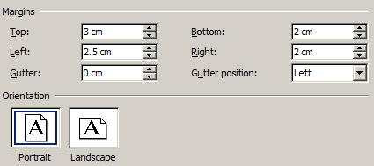
Keywords: (Not more than 5 keywords in a 10-point font size, separated by commas)
Font: Times New Roman
Font size: 10
Alignment: Justify
Line spacing: Single
Page setup
Paper size: A4
Orientation: Portrait

