Presentation type: Oral

The Effect of Corporate Cultural Marketing Activities on Brand Image and Loyalty: Focused on Naver Library, Starfield Library and Hyundai Card Library

Eun-Ah Jeong: Graduate School of Business, Soongsil University, Seoul, Korea, jea7637@nate.com
Jeongil Choi: Corresponding author, College of Business Administration, Soongsil University, Seoul, jichoi@ssu.ac.kr, +82-10-****-****

ABSTRACT
As consumers focus on more culture or esthetics on their decision making, firm becomes to further develop culture marketing as one of brand differentiation strategy. The type of culture marketing of a company is changing from indirect form of support such as cultural sponsorship to direct communication with consumers through the complex culture space of enterprise operation. This study attempts to find how the cultural marketing activities utilizing cultural space affect firm’s brand image and brand loyalty, and whether this culture marketing technique is recognized as a social contribution activity by potential customers and to thereby influence brand image. The study subject includes 200 consumers with experience using the Naver Library, Starfield Library, and Hyundai Card Library. Hypotheses test results using SmartPLS 2.0 show that among cultural marketing factors, cultural support and cultural promotion have little impact on brand image, whereas culture firm influence brand image. Brand image also had an impact on brand loyalty, but it was found that public libraries operated by companies were not recognized as corporate social contribution activities, nor did they have an impact on the formation of the company’s brand image. This study also confirms the coordinating effect of social contribution activities between a cultural firm and its brand image.

KEY WORDS
Brand Image, Brand Loyalty, Complex Cultural Spaces, Cultural Marketing, Social Contribution Activities

- Introduction
As the need for corporate culture marketing becomes increasingly important and social contribution activities are used as part of the company's marketing strategy, cultural marketing as a social contribution activity creates a positive image of the brand and differentiates it from competition among consumers. Social responsibility activities of companies such as charitable work, sponsorship, and volunteer work have been created through the medium of complex cultural spaces. There are about 27 corporate-operated complex cultural spaces in Korea so far, and these facilities provide space for the company's image according to returning firm’s profits to society and high promotion strategies (Heo, 2016). If consumers perceive them as firms’ social responsibility activities, they can improve their image and have a positive impact on their corporate identity, brand attitudes, and willingness to buy (Yoon and Seo, 2003; Creyer and Ross, 1997).
The purpose of this study is to classify the type of culture marketing of companies into cultural support, cultural promotion, and cultural enterprise to demonstrate the effect of each type on brand image formation and brand loyalty. Second, this study aims to examine the impact of brand image formed through corporate cultural marketing on brand loyalty. Third, this study targeted public society library, which is a complex cultural space operated by three companies, such as IT company Naver, distribution company Shinsegae Star Field, and domestic card company Hyundai Card., and it will investigate the impact of public service and public interest on brand image formation.

- Literature Review
2.1 Cultural Marketing
Cultural marketing has evolved into an important strategy for business management by actively reflecting cultural and artistic factors to enhance corporate image or brand beyond the charitable meaning of returning corporate profits to society. This can be seen from the background of cultural marketing, which originated from the name of Macenas, an ancient Roman prime minister who left great achievements in cultural and artistic policy. The concept that a company's Messena activities is a long-term investment for corporate and social symbiosis was initiated in 1994 by the Korea Messena Association, in which a company supports the cultural arts sector and gives some of its profits to the cultural sector (Shim, 2002; Lee, 2003).
According to an analysis by the Korea Messena Association (2017), the most important external factors for cultural management were the increasing social consensus and the expectations of citizens (24.4%). Cultural management as a management trend (17.9%) was also indicated as an important factor. This represents that consumer expectations and social atmosphere are increasingly taking root that corporate cultural marketing will have a significant impact on creating corporate values. Internal factors also show that corporate cultural marketing gradually has a positive effect on internal staff.
In other words, corporate cultural marketing is a modern marketing strategy that persuades consumers by securing market dominance in the long term from a cultural investment perspective, recognizing high quality products, differentiating them from competitors, and building a corporate social contribution image (Lee and Moon, 2008)
2.2 Types of Culture Marketing
The type of culture marketing can be classified according to the method of using marketing or the purpose of marketing as shown in Table 1. In this study, based on the five types of culture marketing, Sales, Sponsored and Style are the three types of cultural marketing activities performed in complex cultural spaces such as Naver library, Starfield library, and Hyundai Card Library.

Table 1. 5 Types of Culture Marketing
Type | Content
Sales | Use culture as an advertising or promotional tool
Sponsorship | Supporting cultural activities or organizations by promoting or enhancing their image
Synthesis | Discrimination by infiltrating a product (service) with a cultural image
Style | Positioning as a company that represents a new and unique culture
Sprit | The cultural appeal of the nation as a halo effect

Sale refers to using elements of culture for advertising or sales promotion, and using an image of cultural orientation to sell products by linking it to a product (service) or brand image. The sales promotion is linked to repeated purchases through purchase leads using price discounts, or brand switches of competing brand buyers, resulting in purchase acceleration and an increase in the total consumption of the product. (Massy and Ronald, 1965). One example of cultural promotion is PPL (Product Placement) strategy, which inserts cultural elements into advertisements or exposes brand products to dramas and movies. In the case of PPL, the impact of the product is huge as it increases awareness of the product by directly exposing it to the consumer.
Sponsorship is the most common and traditional form of cultural marketing that supports cultural and arts organizations to promote or enhance their image (Shim, 2002). As Kim (2006) suggested, culture support is the most common and traditional method of cultural marketing, and this is not only to promote companies through culture but also to emphasize the public interest in promoting their image.
Style is similar to synthesis in that it uses culture to form an image of the company and a brand as a whole, but synthesis connects a brand or product with a cultural code. Style is an effective way to differentiate and increase brand value through a culture that suits the characteristics of companies (Shim, 2002).
2.3 Social Contribution Activities
Corporate social contribution was officially recognized in 1935, and support for culture and art began in earnest after the 1970s. The reason for this is that companies have gradually changed from profit-oriented management systems to management goals and operating systems with emphasis on corporate ethics and social responsibility. In addition, as the importance of corporate brand values and brand image has increased, it has become a strategy to enhance its image and contribute to society through social contribution activities (Heo, 2016).
Recently, corporate social contribution activities have changed from passive attitudes to active forms. It is also referred to as ‘corporate strategy’ because social contribution activities are perceived as an investment concept that enhances corporate value as the interest in social responsibility activities increases.
Carroll (1991), a representative scholar of the firm's corporate social responsibility, explained its social responsibilities using four categories as shown in Figure 1. Lee (2007) also sorted out ethical responsibility, legal responsibilities, economic responsibility, and charitable responsibility for corporate social responsibility.

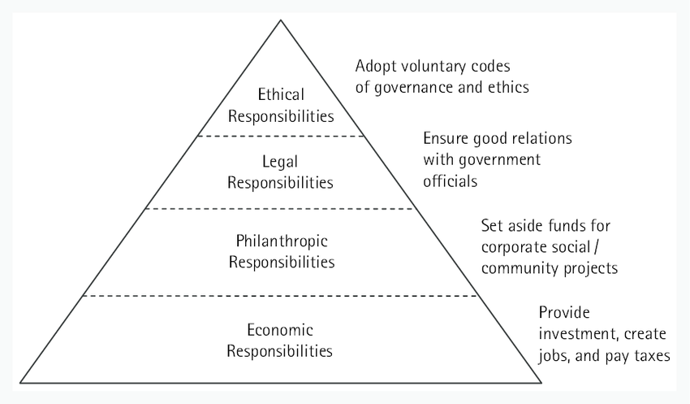
Figure 1. Firm’s Social Responsibility Category

Reference
Alred, G. J., Brusaw, C. T., & Oliu, W. E. (2009). The business writer’s handbook. New York, NY: St Martin's Press.
Best, A. (2004). International history of the twentieth century. Retrieved from http://www.netlibrary.com
Easton, B. (2008). Does poverty affect health? In K. Dew & A. Matheson (Eds.), Understanding health inequalities in Aotearoa New Zealand (pp. 97-106). Dunedin, New Zealand: Otago University Press.
Flesch, R. (n.d.). How to write plain English. Retrieved April 12, 2009, from http://www.mang.canterbury.ac.nz/writing_guide /writing/flesch.shtml
​Global warming. (2009, June 1). Retrieved June 4, 2009, from http://en.wikipedia.org/wiki/Global_warming
Li, S., & Seale, C. (2007). Learning to do qualitative data analysis: An observational study of doctoral work. Qualitative Health Research, 17, 1442–1452. https://doi.org/10.1177/1049732307306924
Radio New Zealand. (2008). Annual report 2007-2008. Retrieved from http://static.radionz.net.nz/assets /pdf_file/0010/179676/Radio_NZ_Annual_Report_2008.pdf
Read, E. (2007, November 1). Myth-busting gen Y. New Zealand Management. Retrieved from http://www.management.co.nz

